# ASSIGNMENT NO-14

* **Problem Statement:- Create an elastic IP for an instance.**
* **Steps:**-
  + **EC2 creation:-**

1. In EC2 dashboard click **launch instances**. Give name,select **ubuntu** for hardware, architecture is 64-bit, instance type is t2.micro.

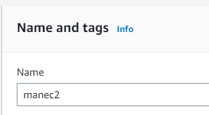 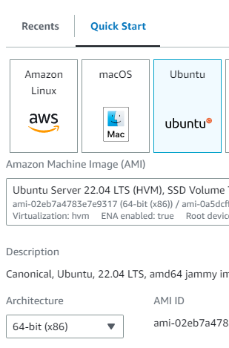

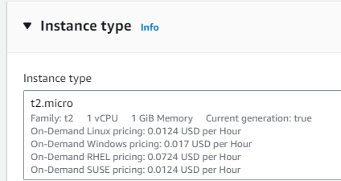

1. Give key pair(in case if u have it give existing one). In Network settings Firewall section click **select existing security group** and select the security group which is created previously(ex-mansecure1).

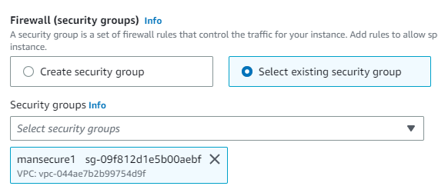

As, we are just checking wheather the IP is elastic or not so no need to give advanced details.

Now, click launch instances and the instance will be created.

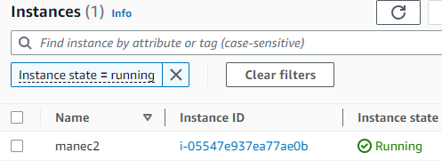

Now, copy public IPv4 address.

**Connect with Bitvise SSH:-**

1. Copy public IPv4 address(ex- 13.234.239.230) and paste it on Bitvise SSH Client.

Give username ubuntu, initial method publickey, in client key manager import that same existed key pair .pem file(ex-key003.pem) and click Global1 in Client key.and click log in.

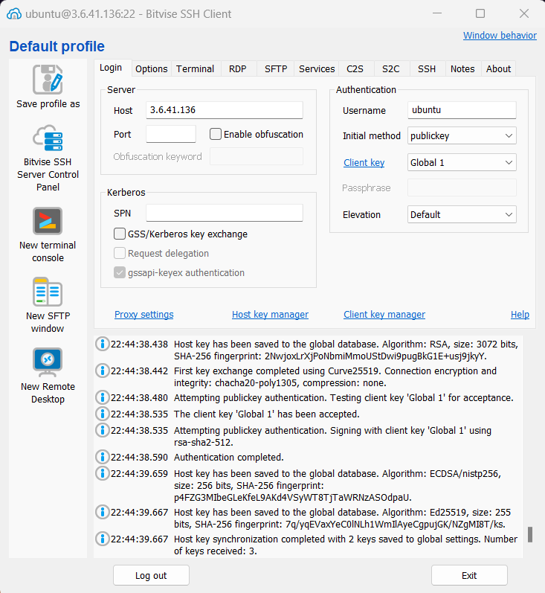

Now, the server is running. copy the IPv4 address and note it. Stop the instance.

And again start the instance. And we can see that the new IP is different from previous one.

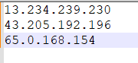

That is the reason why we use **elastic IP**. Elastic IP is a **static** IPv4 addre**ss** which is designed for dynamic cloud computing. As it is static it does

Not change over time which means that it does not change even if we stop or start the instance. This makes it easier to maintain our infrastructure and avoids the need to update the IP address of our resource each time it is restarted.

* **Create Elastic IP**

1. Go to EC2 dashboard and click Elastic IPs. Click “**Allocate Elastic IP address**”. And click **Allocate**.

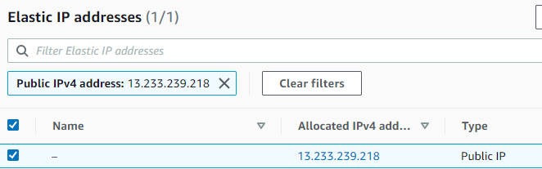

1. Click on Allocated IPv4 address and click “Associated Elastic IP address”.

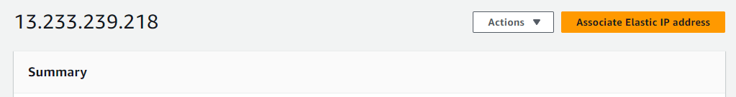

1. Click on instance and select the EC2 which one you want to elastic. Click on Private IP address and click Associate.

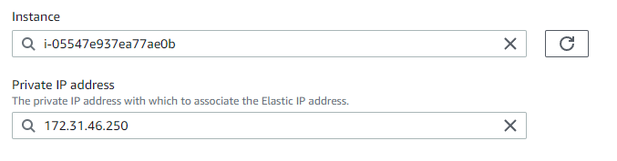

1. We can see that elastic IP is associated with EC2 and if we stop the server it won’t change anymore.

